West Midlands Institute of Psychotherapy

2 Greswolde House, 197b Station Road, Knowle B93 0PU (Registered address)

66 Smirrells Road, Hall Green, Birmingham, B28 0LB (Correspondence address)
Email: admin@wmip.org

www.wmip.org

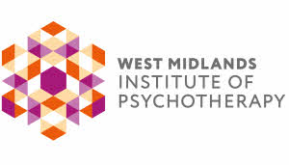
Affiliate Membership Application Form

Member of UK Council for Psychotherapy

Company Limited by Guarantee (No 2883306) Registered Charity (No 1031011)

Personal Details
Title:

Forename(s):
Surname:
Date of Birth:
Address:

Telephone Number:
Email Address:
Current Job Title:
Interest in WMIP:

Event attended:
Safeguarding (Please tick as appropriate)
Have you undergone safeguarding training relevant to your role within the last 3 years?  (This requirement only applies to members who are currently practising) | Yes/No

Please return to admin@wmip.org or by post to West Midlands Institute of Psychotherapy, 66 Smirrells Road, Hall Green, Birmingham, B28 0LB.

Membership fees will be payable on a pro-rata annual, bi-annual or quarterly basis from the end of the month following acceptance.

On receipt of your completed application form you will receive a welcome email from WMIP.

