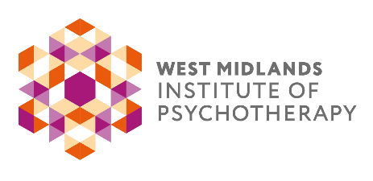
APPLICATION FORM

THE APT: BIRMINGHAM PUBLIC LECTURES 2022/2023

Please tick the lectures you wish to attend:

Lecture 1 Sono Shamdasani / George Bright 5th November 2022
(Booking to be received by 22nd October 2022)

Lecture 2 Judith Anderson 14th January 2023
(Booking to be received by 7th January 2023)

Lecture 3 Dr Christine Driver 4th March 2023
(Booking to be received by 25th February 2023)

Lecture 4 Marica Rytovaara 6th May 2023
(Booking to be received by 29th April 2023)

Lecture 5 Philip Stokoe 10th June 2023
(Booking to be received by 3rd June 2023)

COSTS:-
Lecture 1: £60.00 for WMIP/SAP members and £70.00 for non-WMIP/non-SAP members
This lecture will be held via Zoom Video Conferencing between 10:15 and 15:30.

Lectures 2, 3 and 5: £50.00 for WMIP members and £60.00 for non-WMIP members if attending in person and £45.00 for WMIP members and £55.00 for non-WMIP members if attending via Zoom
These lectures will take place at The Woodbrooke Conference Centre, 1046 Bristol Road, Birmingham B29 6LJ (www.woodbrooke.org.uk) and via Zoom. These lectures will be held between 10:15 – 12:45.

Lecture 4: £45.00 for WMIP members and £55.00 for non-WMIP members
This lecture will be held via Zoom Video Conferencing between 10:15 and 12:45.

A discount of 50% is offered to trainee psychotherapists and other full-time trainees (proof of student/trainee membership is required). This discount is also offered to Retired WMIP members

Title: Name:

Address:

Email: Telephone:

Where did you hear about us?: Therapy Today: JoAP: Past Attendee: Facebook:

Linked In: Other: (please specify):

Your Work or Professional Body: Please tick if WMIP Member

Do you require a certificate of attendance for CPD purposes?: Yes / No

Do you require facilities for the disabled? If so please specify: ____________________________________

Please see overleaf for payment details
Please make your payment by BACS as follows and return your completed form via email.

Bank: Barclays
Sort Code: 20-08-44
Account No: 03737950
Account Name: The Training in Jungian Analytical Psychotherapy
(Please use your name as a reference)

Alternatively send a cheque made payable to 'The Training in Jungian Analytical Psychotherapy' together with your completed form to:

Sue Harford, Administrator to the Training Committee
Unit 1A, West Stockwith Park, Stockwith Road
Misterton, Nottinghamshire. DN10 4ES

Cancellation Policy: All cancellations must be made in writing. Cancellations made no later than three weeks prior to the commencement of the lecture receive a full refund minus an administration fee of £10.00. Cancellations made within 3 weeks of the lecture will not be issued with a refund, but the fee paid can be allocated against a future public lecture.

If you are not a WMIP member, but would like to be kept informed of future events and short courses organised by WMIP committees and members, please delete yes / no below, to confirm how we may contact you.
Read our Privacy Notice at www.wmip.org.

Contact me by email: yes / no by phone: yes / no by post: yes / no

West Midlands Institute of Psychotherapy
2 Greswolde House, 197b Station Road, Knowle, B93 0PU
07903 740512 www.wmip.org admin@wmip.org

