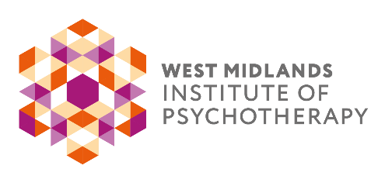
BOOKING FORM

EVENT  Judith Anderson - Reflections on Conducting Assessment for Psychotherapy  DATE & TIME  6th October 2025 7:15 – 8:45pm |  | VENUE  Online via Zoom
FEE
Professionals £30 Members £25 Students £20

PERSONAL DETAILS:
Forename: |  | Surname
Email |  | Phone No.
Address:

WMIP Member | Yes □ No □ | Where did you hear about us?
PAYMENT DETAILS:
Bank Transfer:  Yes □ No □ | Bank: Barclays Account Name: West Midlands Institute of Psychotherapy Sort Code: 20-08-44 Account No:50939145
By Cheque:  Yes □ No □ | Please post your cheque with booking form to West Midlands Institute of Psychotherapy. 66 Smirrells Road, Hall Green, Birmingham, B28 0LB
By Go Cardless:  Yes □ No □ | Please email admin@wmip.org if you would like to pay by Go Cardless and our administrator will make contact.
By Invoice:  Yes □ No □ | If you wish for your company to pay by invoice, please send a purchase order with clear instructions on where to send the invoice, who to address it to and any other information that is required to allow the invoice to be paid to admin@wmip.org:  *Please note: payment needs to be made at least 5 days before the event.
If you are not a WMIP member, but would like to be kept informed of future events and short courses organised by WMIP committees and members, please indicate below, to confirm how we may contact you.
Read our Privacy Notice at www.wmip.org
Contact me by email: Yes □ No □ by phone: Yes □ No □ by post: Yes □ No □

Joining information will be sent out via email to the address provided above. CPD certificates for 1.5 hours can be requested at the email address below after the event. Everyone is welcome to attend. Please do inform us of any mobility issues at time of booking, so we can advise the venue.

